Classroom Job Application
R/ELA
Mme. Leighty
Room 211

Name: Grade: Period:

[A] Position applying for: (please circle)

- Classroom Binder Editor
- Scribe
- Transitions Team
- IT Team/Captain
- Materials Distribution Manager
- Attendance & Absence Monitor
- Maintenance
- Factotum
- Classroom Communications Team

[B] Please list any other jobs, experiences and/or situations that qualify you for the classroom job:

[C] On a separate sheet of paper (preferably typed) write a 2-3 paragraph essay answering the questions below that coordinate with the position(s) for which you are applying:

- How do you plan to organize your time in and out of class to be sure the binder is kept current? [Binder Applicant ONLY]

- How will you maintain your integrity while being responsible for recording student absences and tardies? [Attendance Applicant ONLY]

- What creative or functional ideas do you have to make bulletin boards and the class newsletter as appealing and substantial as possible? [Communications Team Applicant ONLY]

- Why do you think you can handle the added responsibility of this classroom job? [All Applicants]

- What qualities do you have that make you a qualified applicant for this position? [All Applicants]

[D] Write your name legibly on the line after “I”, and sign your name below the paragraph if you agree to the terms of employment.

I, , have read the description of this position, understand how I will be compensated (points in the Assessment category of my R/ELA grade), and agree to fulfill the responsibilities of the position I have applied for, if hired. I understand that if I should fail to live up to these expectations, and/or am continually absent from class, that Mrs. Leighty has the right to hire someone to replace me. I agree to be dependable, honest, trustworthy, confidential, and diligent in all of my classroom job responsibilities.

X____________________________________________________________________ Date:
Classroom Binder Editor
Maintaining the Classroom Binder—30 pts

The editor is responsible for keeping a record of what the class has done every day. Classmates returning from absence should be able to go to the binder and easily understand what they need to do to catch up. The class binder serves as a model of what all students should have in their own binders. You will be responsible for meeting with Mme. Leighty independently to be briefed on job specifics.

Some of these responsibilities include:
File a copy of the scribe’s class notes.
File a copy of all class handouts.
List all page and item numbers and instructions for textbook assignments.
Record homework assignments.

You will be compensated at the end of your quarter-long commitment.

Scribe
Maintaining Class Notes—30 pts

The scribe will take thorough, accurate notes on the day’s agenda and proceedings, make a copy for the Classroom Binder and submit it to the binder editor. In the event of an anticipated absence, you will notify the Factotum in advance.
You will be compensated at the end of your quarter-long commitment.

Transitions Team
Ensuring Purposeful Order in Transition Activities—30 pts

Team members direct and control traffic at doors, monitor formation and orderly maintenance of lines in transit outside the classroom. Occasionally, the classroom will have to be rearranged to accommodate special activities. The transitions team will take charge of the class, supervising a quiet, efficient transition to the purposeful new arrangement. In the event of emergency lockdowns and evacuation drills, the transitions team will ensure quick, quiet compliance with established school procedures. You will be compensated at the end of your quarter-long commitment.

Instructional Technology Team

Assuring Electronic Effectiveness—30 pts

The IT Team is responsible for all aspects of electronic technology in routine classroom activities. They manage and maintain the computer carts, supervising orderly logins at the start of group activities, repairing minor wear and tear on instrument labels, and noting major jobs for school IT personnel. The team operates the timer for classroom competitions and other timed activities. In general, the IT Team ensures the effective operation of classroom devices, maintaining appropriate levels of classroom lighting and operating remotes as needed. You will be compensated at the end of your quarter-long commitment.

Materials Distribution Manager
Distribution and Collection of Class Materials—30 pts

The Materials Distribution Manager is responsible for effective use of classroom supplies. The manager passes out materials for daily exercises and collects completed classwork, monitors and maintains a tidy, adequately stocked supply of materials on the classroom supply table. You will be compensated with at the end of your quarter-long commitment.

Attendance & Absence Monitor
Daily Attendance and Student Make-Up Work—30 pts

The monitor is generally responsible for recording class absences and tardies, as well as for gathering make-up work for those who are absent. The monitor manages the folders of absentees, inserting materials missed during absence. You will be compensated at the end of a quarter-long commitment.

Maintenance Unit
Maintaining Class Vocabulary and Definitions—30 pts

Maintenance and Sanitation Unit members will supervise a responsible tidying up of local spaces at the end of each day’s class. At the change of period, Maintenance Unit members survey the classroom, straightening desks and ensuring that the space is clean and orderly for incoming students. You will be compensated at the end of a quarter-long commitment.

Factotum
Jack or Jill of All Trades—30 to 50 pts

The Factotum, under Mrs. Leighty’s direction, completes exceptional tasks as they arise. The Factotum is competent to assume and capably discharge the duties of any absent student worker. You will be compensated at the end of a quarter-long commitment.

Classroom Communications Team
Ensuring Current Classroom Integration with the Outside World—50 pts

The Classroom Communications Team manages both internal and external classroom publicity. Members design and maintain effective displays of notices on bulletin boards, and they prepare and circulate periodic class newsletters. You will be compensated at the end of a quarter-long commitment.
ation for seeking a position and the question on qualifications for doing the work.

Classified Ads
Classroom Binder Editor | Attendance & Absence Monitor
The editor is responsible for keeping a record of what the class has done every day. Classmates returning from absence should be able to go to the binder and easily understand what they need to do to catch up. The class binder serves as a model of what all students should have in their own binders. You will be responsible for meeting with Mme. Leighty independently to be briefed on job specifics.  Some of these responsibilities include:  File a copy of the scribe’s class notes.  File a copy of all class handouts.  List all page and item numbers and instructions for textbook assignments.  Record homework assignments.  You will be compensated at the end of a quarter-long commitment. | The monitor is generally responsible for recording class absences and tardies, as well as for gathering make-up work for those who are absent. The monitor manages the folders of absentees, inserting materials missed during absence. You will be compensated at the end of a quarter-long commitment.
Scribe | Maintenance Unit
The scribe will take thorough, accurate notes on the day’s agenda and proceedings, make a copy for the Classroom Binder and submit it to the binder editor. In the event of an anticipated absence, you will notify the Factotum in advance. You will be compensated at the end of a quarter-long commitment. | Maintenance and Sanitation Unit members will supervise a responsible tidying up of local spaces at the end of each day’s class. At the change of period, Maintenance Unit members survey the classroom, straightening desks and ensuring that the space is clean and orderly for incoming students. You will be compensated at the end of a quarter-long commitment.
Transitions Team | Factotum
Team members direct and control traffic at doors, monitor formation and orderly maintenance of lines in transit outside the classroom. Occasionally, the classroom will have to be rearranged to accommodate special activities. The transitions team will take charge of the class, supervising a quiet, efficient transition to the purposeful new arrangement. In the event of emergency lockdowns and evacuation drills, the transitions team will ensure quick, quiet compliance with established school procedures. You will be compensated at the end of a quarter-long commitment. | The Factotum, under Mrs. Leighty’s direction, completes exceptional tasks as they arise. The Factotum is competent to assume and capably discharge the duties of any absent student worker. You will be compensated at the end of a quarter-long commitment.
Instructional Technology Team | Classroom Communications Team
The IT Team is responsible for all aspects of electronic technology in routine classroom activities. They manage and maintain the computer carts, supervising orderly logins at the start of group activities, repairing minor wear and tear on instrument labels, and noting major jobs for school IT personnel. The team operates the timer for classroom competitions and other timed activities. In general, the IT Team ensures the effective operation of classroom devices, maintaining appropriate levels of classroom lighting and operating remotes as needed. You will be compensated at the end of a quarter-long commitment. | The Classroom Communications Team manages both internal and external classroom publicity. Members design and maintain effective displays of notices on bulletin boards, and they prepare and circulate periodic class newsletters. You will be compensated at the end of a quarter-long commitment.
Materials Distribution Manager
The Materials Distribution Manager is responsible for effective use of classroom supplies. The manager passes out materials for daily exercises and collects completed classwork, monitors and maintains a tidy, adequately stocked supply of materials on the classroom supply table. You will be compensated at the end of your quarter-long commitment.

Mrs. Leighty’s RELA Classes

Individual Research Project Proposal and Contract

Name(s): __________________________________ Topic: ________________________________________
Project Proposal
Explain your project idea.

Research Plan
How/Where do you plan to gather information for your project?

I understand that the Independent Research Project must include the following elements:
- Multiple and varied sources of information (printed text, video, website, expert, etc.).
- A 2-page minimum research paper with at least four works cited in MLA style.
- A presentation of a product or service based on my learning.
------------------------------------------------------------------------------------------------------------------------------
For Teacher Use Only
Project Approved: Yes ______ No ______
Comments:

------------------------------------------------------------------------------------------------------------------------------
Student Signature_________________________________________
Parent Signature _______________________________
Teacher Signature_________________________________________

Genius Hour Individual Research Project Guidelines

Each quarter, you will conduct a research project in which you explore a topic of personal interest. You will also choose how you plan to present what you have learned.

What is Genius Hour? The Genius Hour grew out of research policies at companies such as Google and 3M. These companies have offered their employees “20% time,” where 20% of their time at work could be spent developing their own company-related projects. Products like Gmail, Google Docs, and Post It notes had their origins in “20% time.”

How will Genius Hour work? Every week, you and your classmates will be given time to explore a topic of your choosing. You will be expected to show evidence of your research and work on your final presentation or product along the way. You will receive formative feedback as the work proceeds.

Genius Hour Process and Checklist:
- Brainstorm topics.
- Choose a topic of focus.
- Create a central question.
- Draft a Genius Hour research proposal.
- Research your topic.
- _______Compile a list of your sources. These will be frame an annotated bibliography.
- Revisit your research proposal and central question (step 4).
- _______Turn in your annotated bibliography.
- Create a final product to show what you learned.
- Present your central question, your research findings, and your final product
to the class.
- Submit a formal written report.

Step 1: Genius Hour Topic Brainstorm
Due Date
Make a list of topics you find interesting in your everyday life. For example, you can choose a sport such as soccer, a hobby such as knitting, a subject such as still life drawing, a world issue such as gender equality, etc.

Step 2: Topic Selection
Due Date
Choose a topic and brainstorm using a Circle or Concept Map.

Step 3: Central Question
Due Date
What specifically do you wish to find out concerning your selected topic? Generate five questions which can be answered through research. They must be broad enough to justify more than a month’s worth of time in exploration, but narrow enough to be answered within that same time frame. Some possible examples include:
- In what ways can gaming help students learn?
- How is schooling different in the United States from schooling in other countries?
- How has skateboarding evolved as a sport?
- The philosopher George Santayana observed that “Those who cannot remember the past are condemned to repeat it.” In what ways has this been true in American/20th Century/Maryland history?

1.

2.

3.

4.

5.

Next, choose one of the central questions you’ve identified. Select one which you are interested in exploring during the quarter.
Circle or highlight your chosen central question in the list above.

Step 4: Research Proposal
Due Date
What is a research proposal? A research proposal is a document created to show what you plan to research, how you plan to research it, and what question(s) you are aiming to answer. There are many ways to construct a research proposal. For the purpose of this project, please follow the format below.

Genius Hour Research Proposal

Topic: What overall topic do you wish to study? This can be one word.

Central Question: What question do you want to answer in your research?

Research Method: How do you plan to research your topic? A thorough project will examine a variety of sources. (Your response in this section should be a fully developed extended paragraph.)

Final Product: What will you create to show what you learned in the course of your research? Be creative. This product will take up at least half of your time and needs to be thorough. The goal of your presentation is to teach your classmates what you have learned. It offers an opportunity to display the expertise you have developed.

The rough draft of your research proposal will be reviewed and returned with recommendations for revision (minor or substantial changes). You will submit a revised final draft for project approval.

Step 5: Research Your Central Question
Due Date
While you research your central question, consider the points below:

  - Where can you gather information to answer your central question?
  - Are there field activities that would help you complete your research?
  - What do you need to know to become an expert on this topic?

Step 6: Compile and Annotate a List of Sources
Due Date
As you collect information to answer your central question, annotate your resources. Organize and present them in a Works Consulted list using MLA format. The list can be handwritten or typed. Your Annotated List of Works Consulted will help you construct your presentation and final product.

Some tips and suggestions:

- Source Cards: Use 3x5” notecards to help you track and organize your sources. On each card, write down document the source in MLA style. See an example below.

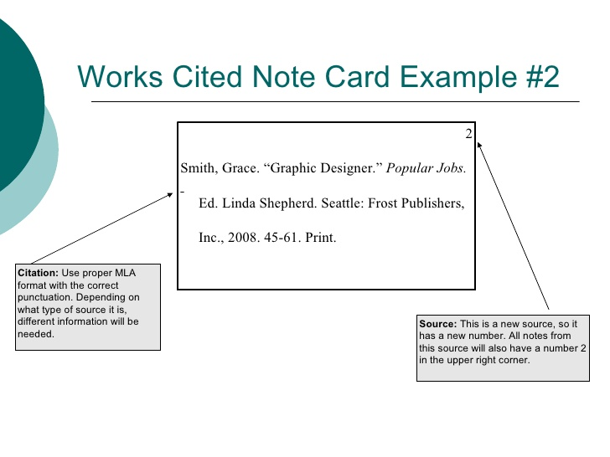
- Note Cards: Use a pack of 3x5” notecards to help you organize your resources. On each card, write down the source, how it relates to the topic, and either a quote from the source or information that will help you in the creation of your final product. See the example below.

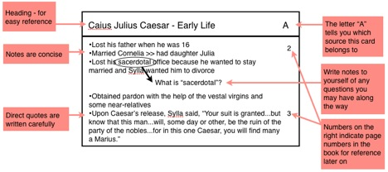

Step 7: Revisit Your Research Proposal and Central Question

Due Date Now that you have conducted some research, is there anything you wish to change regarding your research proposal or central question? If so, amend (change) your research proposal to reflect this. Be sure to indicate that your emendation is a change from the original and explain why you have made it. See the example below:
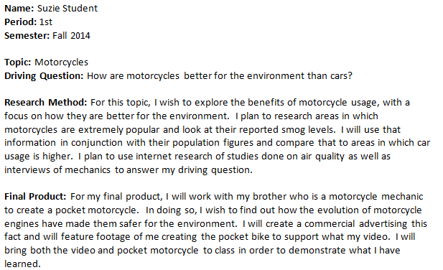
Addendum 10/22/14: After my initial research, I found that all gas- powered vehicles are detrimental to the environment. As a result, I chose to change my research question to “what advances are being made in electric motorcycles?”

Step #8: Turn in Your Annotated Bibliography
Due Date

Your annotated bibliography identifies all the pertinent works you consulted while conducting the research phase of this project. Brief annotations specify the essential value of each source for your inquiry.

Step #9: Create Your Final Product
Due Date

Remember, your final product must match what you described in your research proposal. It should clearly reflect substantial time, effort, and thought.

Step #10: Present Your Central Question, Research Findings, and Final Product

Due Date
Your work will be evaluated, along with the formal written report, using the rubric on the following page.

Step #11: Submit Your Formal Written Report

Due Date

The formal written report, properly formatted in MLA style with a Works Cited page, will count as a significant dimension of your individual research project.
RUBRIC FOR INDIVIDUAL RESEARCH PROJECT
CATEGORY | 4 | 3 | 2 | 1
Research | • Includes four or more varied sources and displays a thorough researching effort. | • Includes three varied sources and displays effort in research. | • Includes two sources and displays little effort in research. | • Includes one source and displays very little effort in research.
Works Cited | • Works Cited included in proper MLA format. | • Works Cited included with minor mistakes in format. | • Works Cited included with several mistakes in format. | • Works Cited included with many mistakes in format.
Oral Presentation | • Holds listeners’ attention with direct eye contact, rarely looking at notes.  • Demonstrates sincere enthusiasm about the topic during the entire presentation.  • Speaks with appropriate modulation in delivery. | • Consistent use of direct eye contact with listeners, but occasionally returns to notes.  • Shows some enthusiasm about the topic.  • Variation of volume and inflection is generally effective. | • Displays minimal eye contact with listeners, while reading mostly from notes.  • Shows scant or mixed feelings about the topic being presented.  • Speaks in uneven volume with little or no inflection. | • Holds no eye contact with listeners, as entire report is read from notes.  • Displays no interest in topic presented.  • Speaks in low volume and/ or monotonous tone.
Knowledge of Content | • Demonstrates full knowledge by answering all class questions with explanations and elaboration. | • Demonstrates some knowledge, and is at ease with expected answers to all questions. | • Seems uncomfortable with information and is able to answer only rudimentary questions. | • Does not display a grasp of information and cannot answer questions about the subject.
Final Product | • The final product is exceptionally attractive in terms of design, layout, neatness, and overall presentation.  • Time and effort exceeds expectations. | • The final product is attractive in terms of design, layout, neatness, and overall presentation.  • Time and effort is evident. | • The final product is somewhat attractive in terms of design, layout, neatness, and overall presentation.  • Reflect some time and effort but clearly needed more. | • The final product lacks attractiveness in terms of design, layout, neatness, and overall presentation. It appears to be rushed and/or incomplete.  • Little or no evidence of time and effort.

R/ELA Vocabulary Study
Name: _________________________________________Date:__________
Latin & Greek Word Sort

Common Element: | Common Element: | Common Element: | Common Element:
Words: | Words: | Words: | Words:

Unit I Vocabulary Cards
You may wish to clip the Unit I vocabulary words below to make flash cards or to help you with sorting.

circumspect | elucidate | improvise | Invidious
lucid | phosphorescent | phototropic | Prospect
photogenic | providential | specter | Translucent

Guided Practice Word Sort:
amiable
enamored
protagonist
philosophical
antagonize
belligerent
amicable
philanthropy
bibliophile
bellicose
antagonist

Sort these words into groups of related words or families. Why did you choose to sort them as you did? What basic meaning or meanings do your sorted words have in common?

(Ideal sort shown below: Latin--BELL—“war,” AM—“love, friend,” Greek--AGON—“contest, struggle,” PHIL—“love”:
BELL AM AGON PHIL
bellicose enamored antagonize philosophical
antebellum amiable protagonist philanthropy
belligerent amicable antagonist bibliophile)

Super Word Web for use in Deep Study: IMPROVISE

Definition: to create and perform (music, drama, or verse) spontaneously or without preparation

IMPROVISE
Example 1: humming when you forget the lyrics to a song
Antonyms:
prepare
plan

Synonyms:
concoct
devise
dream up
throw together

Example 2: using a butter knife for a screw driver

Example 3: telling a story when you’ve forgotten your written speech

Google Classroom Codes

R/ELA 7 H (72)--Period 1
je52qxc

R/ELA 8 H (81)--Period 3
d5mm7hx

R/ELA 7 H (71)--Period 4
5s6yd2m

R/ELA 8 H (82)--Period 5
x1imv59

martha.leighty@pgcps.org

Sign up for important updates from M. Leighty.
Get information for Robert Goddard French Immersion right on your phone—not on handouts.

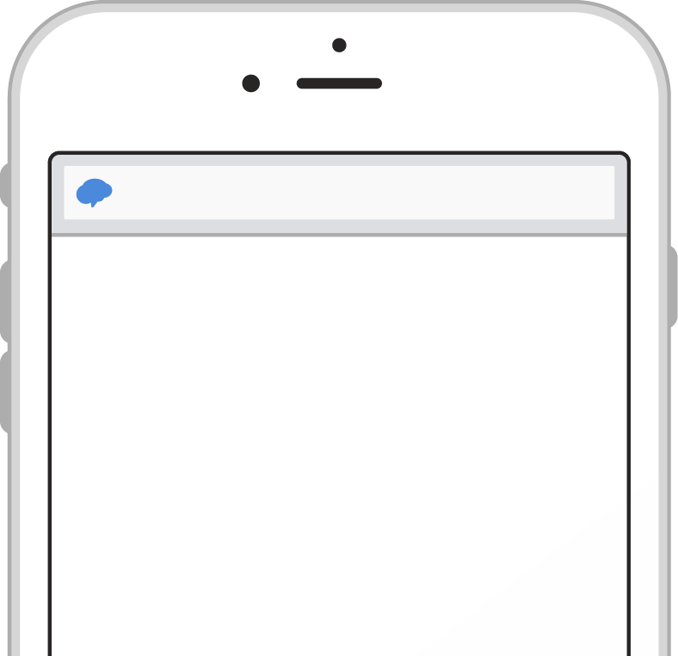
rmd.at/rela7h7
First and Last Name
(555) 555-5555

Pick a way to receive messages for R/ELA 7 H (72)--Period 1:
A
If you have a smartphone, get push
notifications.
On your iPhone or Android phone,
open your web browser and go to the following link:
rmd.at/rela7h7
Join R/ELA 7 H (72)--Period 1

Full Name
Follow the instructions to sign up
for Remind. You’ll be prompted to download the mobile app.
Phone Number or Email Address
B
If you don’t have a smartphone,
get text notifications.
Text the message @rela7h7 to the number
81010.
To
81010
If you’re having trouble with 81010, try texting @rela7h7 to (301) 880-0341.
Message
* Standard text message rates apply.
@rela7h7

Don’t have a mobile phone? Go to rmd.at/rela7h7 on a desktop computer to sign up for email notifications.

Sign up for important updates from M. Leighty.
Get information for Robert Goddard French Immersion right on your phone—not on handouts.

rmd.at/rela8h81
First and Last Name
(555) 555-5555

Pick a way to receive messages for R/ELA 8 H (81)--Period 3:
A
If you have a smartphone, get push
notifications.
On your iPhone or Android phone,
open your web browser and go to the following link:
rmd.at/rela8h81
Join R/ELA 8 H (81)--Period 3

Full Name
Follow the instructions to sign up
for Remind. You’ll be prompted to download the mobile app.
Phone Number or Email Address
B
If you don’t have a smartphone,
get text notifications.
Text the message @rela8h81 to the
number 81010.
To
81010
If you’re having trouble with 81010, try texting @rela8h81 to (301) 880-0341.
Message
* Standard text message rates apply.
@rela8h81

Don’t have a mobile phone? Go to rmd.at/rela8h81 on a desktop computer to sign up for email notifications.

Sign up for important updates from M. Leighty.
Get information for Robert Goddard French Immersion right on your phone—not on handouts.

rmd.at/rela7h71
First and Last Name
(555) 555-5555

Pick a way to receive messages for R/ELA 7 H (71)--Period 4:
A
If you have a smartphone, get push
notifications.
On your iPhone or Android phone,
open your web browser and go to the following link:
rmd.at/rela7h71
Join R/ELA 7 H (71)--Period 4

Full Name
Follow the instructions to sign up
for Remind. You’ll be prompted to download the mobile app.
Phone Number or Email Address
B
If you don’t have a smartphone,
get text notifications.
Text the message @rela7h71 to the
number 81010.
To
81010
If you’re having trouble with 81010, try texting @rela7h71 to (301) 880-0341.
Message
* Standard text message rates apply.
@rela7h71

Don’t have a mobile phone? Go to rmd.at/rela7h71 on a desktop computer to sign up for email notifications.

Sign up for important updates from M. Leighty.
Get information for Robert Goddard French Immersion right on your phone—not on handouts.

rmd.at/rela8h82
First and Last Name
(555) 555-5555

Pick a way to receive messages for R/ELA 8 H (82)--Period 5:
A
If you have a smartphone, get push
notifications.
On your iPhone or Android phone,
open your web browser and go to the following link:
rmd.at/rela8h82
Join R/ELA 8 H (82)--Period 5

Full Name
Follow the instructions to sign up
for Remind. You’ll be prompted to download the mobile app.
Phone Number or Email Address
B
If you don’t have a smartphone,
get text notifications.
Text the message @rela8h82 to the
number 81010.
To
81010
If you’re having trouble with 81010, try texting @rela8h82 to (301) 880-0341.
Message
* Standard text message rates apply.
@rela8h82

Don’t have a mobile phone? Go to rmd.at/rela8h82 on a desktop computer to sign up for email notifications.

Khan Academy—PSAT Prep & Grammar

